COINS-Constantine I (306-337)-AE3-Trier-two soldiers, two standards, no drapery, thin shafts-RIC 537

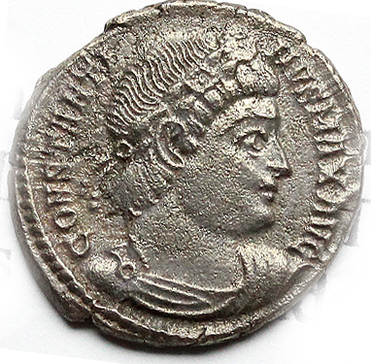 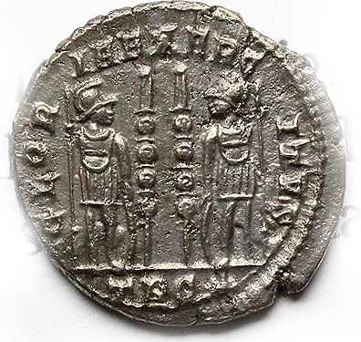

REV: Two soldiers holding spears and shields on either side of two military standards - GLORIA EXERCITVS

Obverse: CONSTANTINVS MAX AVG. Rosette-diademed, draped, cuirassed bust right.

Reverse: GLORIA EXERCITVS. two soldiers holding spears and shields with two standards between them. Standards have no drapery and very thin shafts with pointed tops instead of banners. Mintmark: TR dot S.

Superb coin, practically uncirculated, in EF+ condition, conserving absolutely full details in both sides, super bold reliefs and delicious dark brown patina.

RIC VII 537.  Treveri mint, Bronze, A.D. 330-335.  2,0 g - 16 mm

AP 1